
CE-221 Digital Logic Design
Course Instructor: Dr. Adnan Shah

Smart Doorbell with Visitor Indication

Submitted by:
Rabia Ashraf - 2024527
Qurat Ulain Ahmed - 2024526
Introduction:
A smart doorbell is a simple, yet important home-automation device designed to alert the homeowner when a visitor arrives. This project focuses on creating a Smart Doorbell with Visitor Indication, which not only rings when someone presses the switch, but also has a counter via JK flipflop that shows the number of times the doorbell has been pressed until the fourth press, after which it resets again. This system is useful for homes, small offices, shops etc.

Project Description:
2.1 Objective
The main objective of this project is to design a simple and reliable smart doorbell system that:
- Alerts the user through a buzzer when the doorbell button is pressed.
- Provides the number of times the doorbell has been rung via LEDs.
- Ensures low cost, easy installation, and user-friendly operation

2.2 Components
- JK Flip-Flop IC (74HC76)
- NOT Gate IC (74HC04)
- LEDs
- Resistors (10k, 1k, 220 ohm)
- Pushbutton (ACTIVE)
- Transistor (2N2222)
- Buzzer
- Battery Power Supply (9V) with 5V Convertor
- Breadboard
- Jumper Wires

2.3 Working Principle
When a visitor presses the push button, the circuit is completed, allowing current to flow. This activates two things simultaneously:
- The buzzer rings, producing an audible alert.
- The Counter shows the number of times the bell has been pressed by LEDs, using a dual J-K flipflop.

2.4 Block Diagram

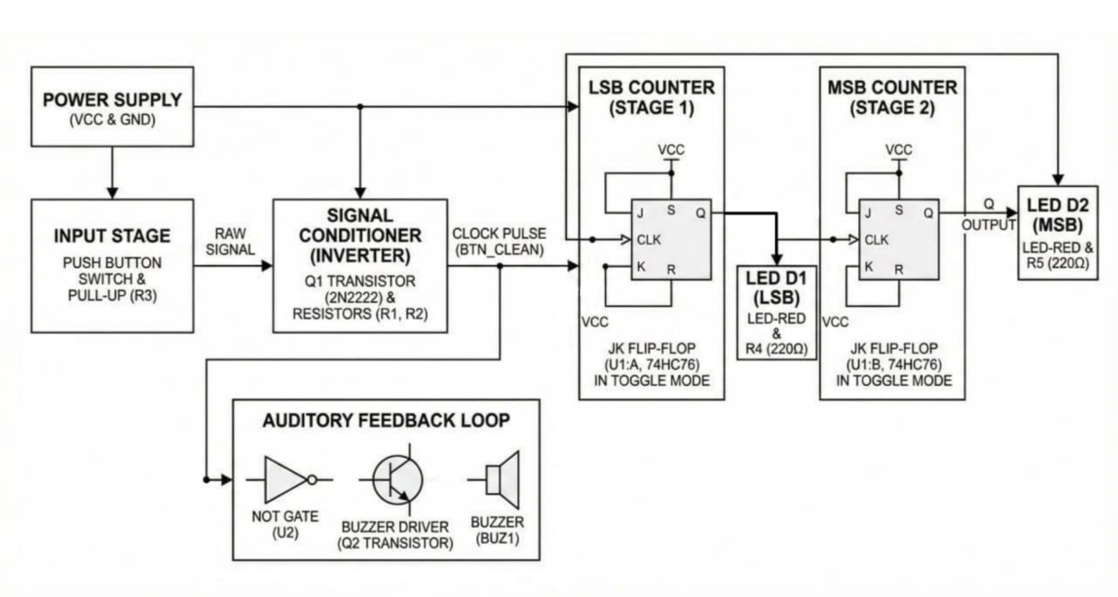

2.5 Schematics
Simulation:
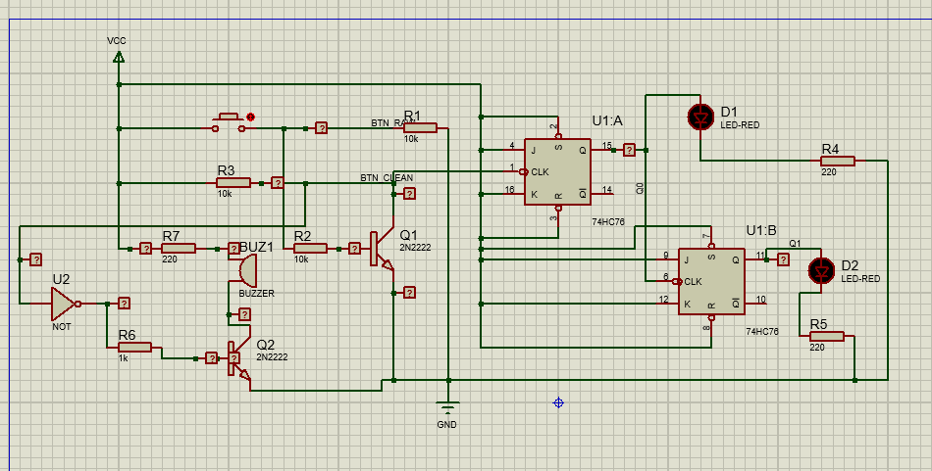

- When the button has not been pressed:
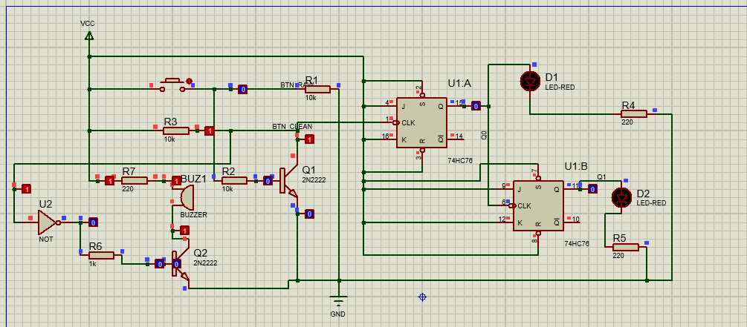

- First press of the button : lights up the first LED 1, indicating ‘1’/ ‘01’.
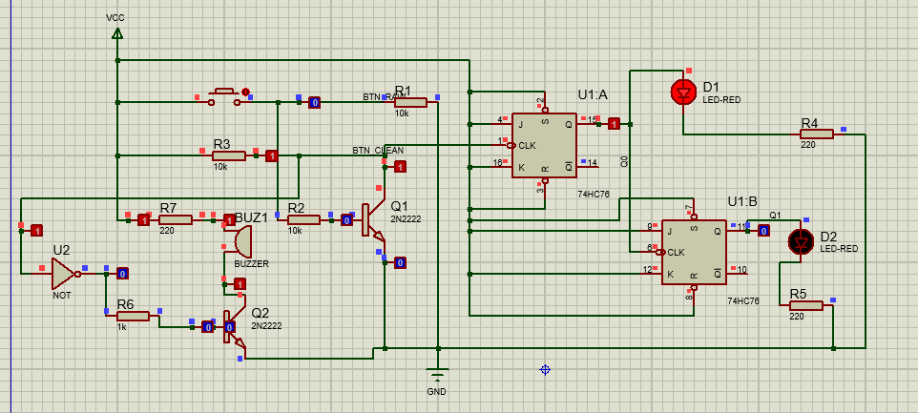

- Second press of the button : lights up the second LED 2, indicating ‘2’/ ‘10’.
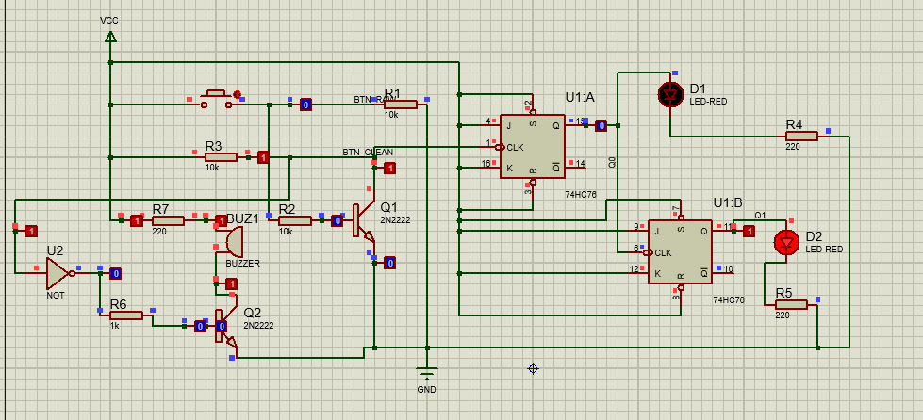

- Third press of the button : lights up both LEDs (1 and 2), indicating ‘3’/ ‘11’.
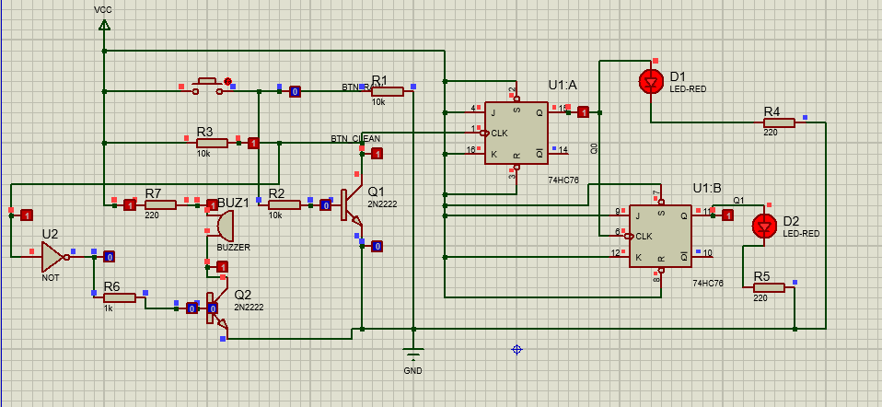

- Fourth press of the button : resets back to zero.
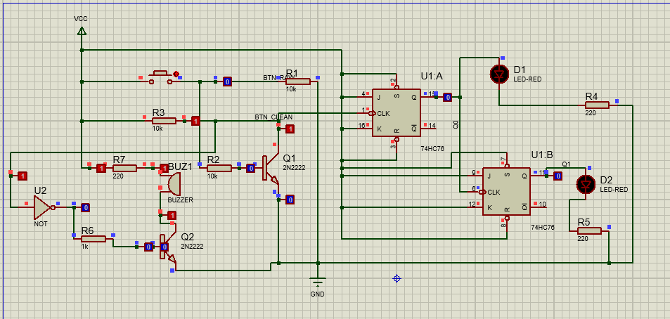

2.6 Features
- Low-cost and easy to build
- Dual indication: Sound + Visual
- Suitable for homes, shops, and offices as
- Low power consumption
- Easy installation and maintenance

References:
- https://youtu.be/0u9jpb2WlCY?si=_p2trThEftkGSgvt

- https://www.electronicsforu.com/electronics-projects/doorbell-cum-visitor-indicator

